<INSERT ORGANISATION> Risk Management Policy

1. PURPOSE
The purpose of this risk management policy is to communicate <INSERT ORGANISATION NAME>'s commitment to managing enterprise-wide risks and to establish clear responsibilities for itself in order to maximize strategic and operational achievement.

2. SCOPE AND CONTEXT
This policy applies to directors, management and staff of <INSERT ORGANISATION NAME>.
<INSERT ORGANISATION NAME> is committed to the formal, systematic and structured proactive management of risks across the organisation.
Risk is inherent in all aspects of <INSERT ORGANISATION NAME>'s activities and whilst many of these risks cannot be eliminated, they can, however, be identified, quantified and controlled. Risks that impact on the objectives of <INSERT ORGANISATION NAME> can offer both opportunity and threat. This policy is designed to provide <INSERT ORGANISATION NAME> personnel with a systematic framework in order to minimise threats and maximise opportunities to <INSERT ORGANISATION NAME>.

3. KEY OBJECTIVES
a. The Risk Management Standard (AS/NZS ISO 31000:2009) defines risk management as “coordinated activities to direct and control an organisation with regard to risk”.
b. This policy confirms that <INSERT ORGANISATION NAME> is committed to implementing a strategic, consistent and structured enterprise-wide approach to risk management in order to effectively manage opportunities for gain and minimise the impact of threats causing losses.
c. This policy is aligned to reflect AS/NZS ISO 31000:2009 Risk Management – Principles and Guidelines which provides the framework used to develop the <INSERT ORGANISATION NAME> enterprise-wide risk management framework.
d. Risk will manifest itself in many forms and has the potential to impact the health and safety, environment, community, reputation, regulatory, operational, and financial performance of <INSERT ORGANISATION NAME> and, thereby, the achievement of the organisation's objectives.
e. By understanding and managing risk, <INSERT ORGANISATION NAME> will provide greater certainty and confidence for our stakeholders, <INSERT ORGANISATION NAME> directors and employees, participants, and for the communities in which we operate.
f. <INSERT ORGANISATION NAME> will use our risk management capabilities to maximise the value from our assets, projects, programs and other business opportunities and to assist us in fostering participation and/or performance in our organisation.
g. Risk management will be embedded into our business activities, functions and processes. Risk understanding and our tolerance for risk will be key considerations in our decision making.
h. Risk issues will be identified, analysed and ranked in a consistent manner. Common systems and methodologies will be used.
i. Risk controls will be designed and implemented to reasonably assure the achievement of organisational objectives. The effectiveness of these controls will be systematically reviewed and, where necessary, improved.
j. Risk management performance will be monitored, reviewed and reported. Oversight of the effectiveness of our risk management processes will provide assurance to executive management, the Board and relevant stakeholders.
k. The effective management of risk is vital to the continued growth and success of [ORGANISATION NAME].

4. REVIEW OF POLICYKEY OBJECTIVES
This policy is subject to formal review every [NUMBER] years.

5. ACCESS TO THE POLICY
This policy will be available for viewing to any director or employee of [ORGANISATION NAME]. In addition, this policy may be made available to any third party at the discretion of the [ORGANISATION NAME] Chief Executive Officer.

6. RISK MANAGEMENT PROCESS AND PROCEDURES
The directors and management of <INSERT ORGANISATION NAME> view risk management as integral to its strategic intent of <INSERT VISION AND OR PURPOSE STATEMENT> by:
A. <Insert critical success factor>
B. <Insert critical success factor>
C. <Insert critical success factor>
D. <Insert critical success factor>
E. <Insert critical success factor>
<INSERT ORGANISATION NAME>'s risk management policy provides a system to manage the risks associated with its core activities.

7. RISK MANAGEMENT REQUIREMENTS
a. Risk management will be incorporated into the strategic and operational planning processes of <INSERT NAME\ ORGANISATION>;
b. Risk and the management of risk will be identified and monitored according to the <INSERT NAME\ ORGANISATION> enterprise-wide risk management policy;
c. Risk assessments will be conducted on all new ventures and projects prior to commencement to ensure alignment with the <INSERT NAME\ ORGANISATION> risk appetite and organisational objectives;
d. Risks will be identified, reviewed and monitored on an ongoing basis as outlined in Sections 10 to 15 of this policy;
Here is the transcription of the text from the image image_081840.jpg:
e. Risks will be assessed and evaluated against the <INSERT NAME ORGANISATION> Risk Management Framework (outlined in section 15 of this policy);
f. Relevant risks that are identified will be recorded within <INSERT NAME ORGANISATION>'s risk management register;
g. All risks will be assigned an owner whose responsibilities are specified in this policy under section 14 of this policy.

8. RISK MANAGEMENT PRINCIPLES
<INSERT NAME ORGANISATION> has adopted the principles detailed in AS/NZS ISO 31000:2009, to ensure risk management is effective within the organization. These principles are:
a) Risk management creates and protects value
b) Risk management is part of decision making
c) Risk management explicitly addresses uncertainty
d) Risk management is systematic, structured and timely
e) Risk management is based on the best available information
f) Risk management is tailored
g) Risk management takes human and cultural factors into account
h) Risk management is transparent and inclusive
i) Risk management is dynamic, iterative and responsive to change
j) Risk management facilitates continual improvement of the organisation

9. RISK MANAGEMENT PROCESS
The <INSERT NAME ORGANISATION> risk management process is based upon the AS/NZS ISO 31000:2009 Risk Management Process as shown in Figure 1 (below). Risks identified will be managed according to this process and comprises the following stages:

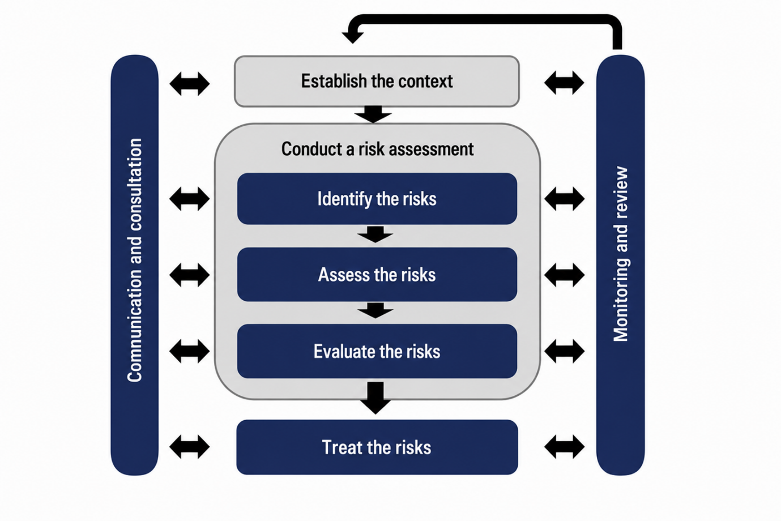
Above: AS/NZS ISO 31000:2009 Risk Management Process

  - Communicate and consult - with internal and external stakeholders at each stage of the process
  - Establish the context - define the external, internal and risk management context, and the criteria against which risk will be evaluated
  - Identify risks - determine what, where, when, why and how events could affect the achievement of objectives
  - Analyse risks - determine the likelihood and consequence of identified risks, and the existing controls
  - Evaluate risks - compare the level of risk against the risk criteria, and determine treatment priorities
  - Treat risks - select and implement options for addressing risk
  - Monitor and review - track the performance of controls and treatments, and identify changes in context

This process is to be applied consistently across all business units and at all levels of <INSERT ORGANISATION NAME>, supported by the detailed procedures in Sections 10 to 15.

10. RISK IDENTIFICATION
Risks will be identified through a combination of methods, including workshops, management interviews, incident and near-miss reporting, audit findings, project planning activities, and analysis of the external operating environment. Risks may be identified by any director, manager or employee at any time, and must be reported to the relevant risk owner or the Executive/Risk Committee for inclusion in the risk register.
Risks should be identified across the following categories, as relevant to <INSERT ORGANISATION NAME>:
- Strategic - risks affecting long-term goals and competitive position
- Operational - risks affecting day-to-day business processes and service delivery
- Financial - risks affecting funding, cash flow, and financial sustainability
- Compliance / Regulatory - risks of breaching laws, regulations or licence conditions
- Health and Safety - risks to the wellbeing of staff, participants and the public
- Reputational - risks affecting public trust and confidence in the organisation
- Technology / Information - risks to data, systems and information security

11. RISK ANALYSIS AND RISK MATRIX
Once identified, each risk is analysed by assessing its likelihood of occurring and the consequence should it occur, using the rating scales below. The combination of likelihood and consequence determines the overall risk rating, as shown in the risk matrix.
Likelihood/Consequence | Insignificant | Minor | Moderate | Major | Severe
Almost Certain | Moderate | High | High | Extreme | Extreme
Likely | Moderate | Moderate | High | High | Extreme
Possible | Low | Moderate | Moderate | High | Extreme
Unlikely | Low | Low | Moderate | Moderate | High
Rare | Low | Low | Moderate | Moderate | High

Risk Rating | Required Management Response
Low | Manage through routine procedures. Unlikely to require specific application of resources. Monitor and review as part of normal operations.
Moderate | Management responsibility specified. Manage by specific monitoring or response procedures. Review at next scheduled risk review.
High | Requires senior management attention. A documented risk treatment plan must be developed, with a nominated owner and timeframe, and reported to the <INSERT ORGANISATION NAME> Executive/Risk Committee.
Extreme | Immediate action required. Must be escalated to the Board/Chief Executive Officer. A detailed treatment plan with regular monitoring and reporting is mandatory.

12. RISK EVALUATION
Following analysis, each risk is evaluated against <INSERT ORGANISATION NAME>'s risk appetite and tolerance levels to determine whether the existing level of risk is acceptable, or whether further treatment is required. Risks rated High or Extreme will always require a documented treatment plan. Risks rated Low or Moderate may be accepted and managed through routine business processes, subject to periodic review.

13. RISK TREATMENT
Where treatment is required, risk owners will select one or more of the following treatment options, taking into account the cost and benefit of the action:
- Avoid the risk - by deciding not to proceed with the activity
- Reduce the risk - by implementing controls to reduce likelihood and/or consequence
- Transfer the risk - for example, through insurance or contractual arrangements
- Accept the risk - where the level of risk is within ${ORG}'s risk appetite
All treatment plans must specify the action to be taken, the resources required, the responsible owner and the target completion date. Progress on treatment plans will be reported at each scheduled risk review.

14. ROLES AND RESPONSIBILITIES
Role | Risk Management Responsibilities
Board of Directors | Approves this policy and the <INSERT ORGANISATION NAME> risk appetite; oversees the effectiveness of the enterprise-wide risk management framework; receives reports on extreme and high rated risks.
Chief Executive Officer | Holds overall accountability for risk management across <INSERT ORGANISATION NAME>; ensures adequate resources are allocated to risk management activities; escalates extreme risks to the Board.
Executive / Risk Committee | Reviews the risk register on a regular basis; approves treatment plans for high and extreme risks; monitors the effectiveness of controls; reports to the Board.
Risk Owners (Management) | Identify, assess and document risks within their area of responsibility; implement and maintain risk treatments and controls; report changes in risk status; maintain accurate entries in the risk register.
All Staff | Identify and report risks and incidents as they arise; comply with risk controls, procedures and instructions; participate in risk management training as required.
Internal Audit (if applicable) | Provides independent assurance on the design and operating effectiveness of risk controls and the risk management framework.

15. RISK MANAGEMENT FRAMEWORK SUMMARY
The <INSERT ORGANISATION NAME> risk management framework is built on the AS/NZS ISO 31000:2009 Risk Management Process (see Section 9), supported by the risk matrix and rating criteria in Section 11, and implemented through the roles and responsibilities described in Section 14.
Risk ID | Risk Description | Category | Likelihood | Consequence | Rating | Existing Controls | Treatment / Action | Owner | Review Date
The framework is operationalised through the <INSERT ORGANISATION NAME> Risk Register, which is the central record of all identified risks, their ratings, controls and treatment plans. A template extract of the register is shown below; the live register is maintained separately by <INSERT RESPONSIBLE TEAM/ROLE>.

Policy Approval
Approved by: ___________________________ Position: ___________________________
Signature: ______________________________ Date: ______________________________

